Operations Management, 10e, Global Edition (Heizer/Render)
Chapter 3 Project Management

1) The ES of an activity that has only one predecessor is simply the EF of that predecessor.
Answer: TRUE
Diff: 2
Topic: Determining the project schedule
Objective: LO3-3

2) One phase of a large project is scheduling.
Answer: TRUE
Diff: 1
Topic: The importance of project management
Objective: no LO

3) A project organization works best for an organization when the project resides in only one of its functional areas.
Answer: FALSE
Diff: 2
Topic: Project planning
Objective: no LO

4) By their very nature, projects have a limited lifetime, and that sets project management apart from the management of more traditional activities.
Answer: TRUE
Diff: 2
Topic: Project planning
Objective: no LO

5) One responsibility of a project manager is to make sure that the project meets its quality goals.
Answer: TRUE
Diff: 2
Topic: Project planning
Objective: no LO

6) Work Breakdown Structure is a useful tool in project management because it addresses the timing of individual work elements.
Answer: FALSE
Diff: 2
Topic: Project planning
Objective: no LO

7) Project managers have their own code of ethics, established by the Project Management Institute.
Answer: TRUE
Diff: 2
Topic: Ethical issues faced in project management
AACSB: Ethical Reasoning
Objective: no LO
8) Ethical issues which can arise in projects include gifts from contractors, pressure to mask delays with false status reports, and pressure to compromise project quality for cost or time savings.
Answer: TRUE
Diff: 1
Topic: Ethical issues faced in project management
AACSB: Ethical Reasoning
Objective: no LO

9) Gantt charts give a timeline for each of a project's activities, but do not adequately show the interrelationships of activities.
Answer: TRUE
Diff: 2
Topic: Project scheduling
Objective: LO3-1

10) PERT, but not CPM, has the ability to consider the precedence relationships in a project.
Answer: FALSE
Diff: 2
Topic: Project scheduling
Objective: LO3-5

11) The shortest of all paths through the network is the critical path.
Answer: FALSE
Diff: 2
Topic: Project management techniques: PERT and CPM
Objective: LO3-4

12) The fundamental difference between PERT and CPM is that PERT uses the beta distribution for crashing projects while CPM uses cost estimates.
Answer: FALSE
Diff: 2
Topic: Project management techniques: PERT and CPM
Objective: LO3-5

13) Slack is the amount of time an activity can be delayed without delaying the entire project.
Answer: TRUE
Diff: 2
Topic: Project management techniques: PERT and CPM
Objective: LO3-3

14) Every network has at least one critical path.
Answer: TRUE
Diff: 2
Topic: Project management techniques: PERT and CPM
Objective: LO3-4
15) The critical path can be determined by use of either the "forward pass" or the "backward pass."
Answer: FALSE
Diff: 2
Topic: Project management techniques: PERT and CPM
Objective: LO3-4
16) The PERT pessimistic time estimate is an estimate of the minimum time an activity will require.
Answer: FALSE
Diff: 1
Topic: Project management techniques: PERT and CPM
Objective: LO3-5

17) The standard deviation of project duration is the average of the standard deviation of all activities on the critical path.
Answer: FALSE
Diff: 2
Topic: Project management techniques: PERT and CPM
Objective: LO3-5

18) In PERT analysis, the identification of the critical path can be incorrect if a noncritical activity takes substantially more than its expected time.
Answer: TRUE
Diff: 3
Topic: Project management techniques: PERT and CPM
Objective: LO3-5

19) Shortening the project's duration by deleting unnecessary activities is called "project crashing."
Answer: FALSE
Diff: 2
Topic: Cost-time trade-offs and project crashing
Objective: LO3-6

20) In project management, crashing an activity must consider the impact on all paths in the network.
Answer: TRUE
Diff: 2
Topic: Cost-time trade-offs and project crashing
Objective: LO3-6

21) Which of the following statements regarding Bechtel is true?
A) Its competitive advantage is project management.
B) Bechtel was the construction contractor for the Hoover Dam.
C) While helping to rebuild Iraq, Bechtel's crews had to travel under armed escort.
D) Bechtel's procurement program is global in nature.
E) All of the above are true.
Answer: E
Diff: 1
Topic: Global company profile
Objective: no LO
22) Which of the following statements about Bechtel is true?
A) Even though Bechtel is over 100 years old, the Kuwaiti oil fields was its first "project."
B) Bechtel is the world's premier manager of massive construction and engineering projects.
C) Bechtel's competitive advantage is supply-chain management.
D) While its projects are worldwide, its network of suppliers is largely in the U.S.
E) All of the above are true.
Answer: B
Diff: 2
Topic: Global company profile
Objective: no LO

23) Which of the following projects were completed by Bechtel?
A) Hoover Dam
B) Boston Central Artery/Tunnel
C) Rebuilding Kuwait after Iraq's invasion in 1990
D) Rebuilding Iraq after the U.S. invasion, starting in 2003
E) All of the above were Bechtel projects
Answer: E
Diff: 2
Topic: Global company profile
Objective: no LO

24) The phases of project management are
A) planning, scheduling, and controlling
B) planning, programming, and budgeting
C) planning, organizing, staffing, leading, and controlling
D) different for manufacturing projects than for service projects
E) GANTT, CPM, and PERT
Answer: A
Diff: 1
Topic: The importance of project management
Objective: no LO

25) Which of the following is not one of the three phases of project management?
A) planning
B) scheduling
C) controlling
D) All of the above are project management phases.
E) Both A and C are not project management phases.
Answer: D
Diff: 2
Topic: The importance of project management
Objective: no LO
26) A project organization
A) is effective for companies with multiple large projects
B) is appropriate only in construction firms
C) often fails when the project cuts across organizational lines
D) is formed to ensure that programs (projects) get proper management and attention
E) A and D are both true
Answer: E
Diff: 2
Topic: Project planning
Objective: no LO

27) Which of the following statements regarding project management is false?
A) Gantt charts give a timeline for each of a project's activities, but do not adequately show the interrelationships of activities.
B) A project organization works best for a project that is temporary but critical to the organization.
C) Project organization works well when the work contains simple, independent tasks.
D) Gantt charts and PERT/CPM are never used together.
E) None of the above is true.
Answer: C
Diff: 2
Topic: Project planning
Objective: no LO

28) A code of ethics especially for project managers
A) has been established by the Project Management Institute
B) has been formulated by the Federal government
C) has been formulated by the World Trade Organization
D) is inappropriate, since everyone should use the same guidance on ethical issues
E) does not exist at this time
Answer: A
Diff: 2
Topic: Project planning
AACSB: Ethical Reasoning
Objective: no LO

29) Ethical issues that may arise in projects large and small include
A) gifts from contractors
B) exaggerated expense reports
C) compromised safety or health standards to save time or reduce costs
D) pressure to mask delays with false status reports
E) all of the above
Answer: E
Diff: 1
Topic: Project planning
AACSB: Ethical Reasoning
Objective: no LO
30) The project organization works best when which of the following conditions are satisfied?
I. Work can be defined with a specific goal and deadline.
II. The job is typical and familiar to the existing organization.
III. The work contains interrelated tasks requiring specialized skills
IV. The project is temporary but unimportant to long-term organizational success
V. The project cuts across organizational lines.
A) I,II,III,IV,V
B) None of the above conditions need to be satisfied
C) I,III,V
D) I,II,III,V
E) I,III,IV,V
Answer: C
Diff: 2
Topic: Project planning
Objective: no LO

31) A project organization that becomes permanent is often referred to as a __________.
A) fixed project organization
B) matrix organization
C) normal organization
D) standard organization
E) none of the above
Answer: B
Diff: 2
Topic: Project planning
Objective: no LO

32) WBS stands for which of the following project management tools?
A) Work Break Schedule
B) Work Breakdown Status
C) Work Breakdown Schedule
D) Work Breakdown Structure
E) None of the above
Answer: C
Diff: 2
Topic: Project planning
Objective: no LO
33) Match the following steps in Microsoft's development of Windows 7 to their respective WBS level.

Step Level
Develop Windows 7 OS ?
System Testing ?
Compatible with Windows XP ?
Develop GUI's ?
Module Testing ?
A) Level 1, Level 2, Level 4, Level 3, Level 3
B) Level 1, Level 2, Level 3, Level 4, Level 5
C) Level 0, Level 1, Level 2, Level 3, Level 4
D) Level 0, Level 2, Level 2, Level 3, Level 3
E) None of the above patterns is correct.
Answer: A
Diff: 3
Topic: Project planning
Objective: no LO

34) A combination of effective Gantt chart use and other tactics allowed Delta to cut the average time for a plane layover by what % of the original 60 minute duration?
A) 33%, to 40 minutes
B) 50%, to 30 minutes
C) 20%, to 48 minutes
D) 25%, to 45 minutes
E) 40%, to 36 minutes
Answer: A
Diff: 2
Topic: Project scheduling
Objective: LO3-1

35) Which of the following statements regarding Gantt charts is true?
A) Gantt charts give a timeline and precedence relationships for each activity of a project.
B) Gantt charts use the four standard spines of Methods, Materials, Manpower, and Machinery.
C) Gantt charts are visual devices that show the duration of activities in a project.
D) Gantt charts are expensive.
E) All of the above are true.
Answer: C
Diff: 2
Topic: Project scheduling
Objective: LO3-1
36) The main difference between PERT and CPM is that
A) PERT is more accurate than CPM
B) PERT assumes that activity durations are known
C) PERT ignores activity costs
D) CRM assumes activity durations can vary
E) None of the above are true
Answer: E
Diff: 2
Topic: Project management techniques: PERT and CPM
Objective: no LO

37) A project manager is interested in crashing a project with variable activity times. Which of the following tools should he/she employ?
A) PERT
B) CPM
C) Gantt Chart
D) either PERT or CPM
E) PERT, CPM, or a Gantt chart are fine
Answer: A
Diff: 2
Topic: Project management techniques: PERT and CPM
Objective: LO3-6

38) The difference between AON and AOA networks is that
A) AOA networks sometimes require dummy nodes
B) nodes consume no resources or time in AOA networks
C) both are acceptable in practice, however Microsoft Project uses AON
D) in AON nodes designate activities, in AOA arrows designate activities
E) All of the above are true.
Answer: E
Diff: 2
Topic: Project management techniques: PERT and CPM
Objective: LO3-2

39) Which of the following statements regarding critical paths is true?
A) The shortest of all paths through the network is the critical path.
B) Some activities on the critical path may have slack.
C) Every network has only one critical path.
D) On a specific project, there can be multiple critical paths, all with exactly the same duration.
E) The duration of the critical path is the average duration of all paths in the project network.
Answer: D
Diff: 2
Topic: Project management techniques: PERT and CPM
Objective: LO3-4
40) Which of the following statements regarding CPM is true?
A) The critical path is the shortest of all paths through the network.
B) The critical path is that set of activities that has positive slack.
C) Some networks have no critical path.
D) All activities on the critical path have their LS equal their predecessor's EF.
E) All of the above are false.
Answer: D
Diff: 2
Topic: Project management techniques: PERT and CPM
Objective: LO3-4

41) A simple CPM network has three activities, A, B, and C. A is an immediate predecessor of B and of C. B is an immediate predecessor of C. The activity durations are A=4, B=3, C=8.
A) The critical path is A-B-C, duration 15.
B) The critical path is A-C, duration 12.
C) The critical path is A-B-C, duration 13.5
D) The critical path cannot be determined without knowing PERT expected activity times.
E) The network has no critical path.
Answer: A
Diff: 3
Topic: Project management techniques: PERT and CPM
AACSB: Analytic Skills
Objective: LO3-4

42) A simple CPM network has three activities, D, E, and F. D is an immediate predecessor of E and of F. E is an immediate predecessor of F. The activity durations are D=4, E=3, F=8.
A) The critical path is D-E-F, duration 15.
B) The critical path is D-F, duration 12.
C) Slack at D is 3 units.
D) Slack at E is 3 units.
E) Both a and c are true.
Answer: A
Diff: 3
Topic: Project management techniques: PERT and CPM
AACSB: Analytic Skills
Objective: LO3-4

43) A simple CPM network has five activities, A, B, C, D, and E. A is an immediate predecessor of C and of D. B is also an immediate predecessor of C and of D. C and D are both immediate predecessors of E.
A) There are two paths in this network.
B) There are four paths in this network.
C) There are five paths in this network.
D) There are 25 paths through this network.
E) None of these statements is true.
Answer: B
Diff: 2
Topic: Project management techniques: PERT and CPM
AACSB: Analytic Skills
Objective: LO3-3
44) Activity D on a CPM network has predecessors B and C, and has successor F. D has duration 6. B's earliest finish is 18, while C's is 20. F's late start is 26. Which of the following is true?
A) B is a critical activity.
B) C is completed before B.
C) D has no slack but is not critical.
D) D is critical, and has zero slack.
E) All of the above are true.
Answer: D
Diff: 3
Topic: Project management techniques: PERT and CPM
AACSB: Analytic Skills
Objective: LO3-4

45) Which of the following statements regarding CPM networks is true?
A) There can be multiple critical paths on the same project, all with different durations.
B) The early finish of an activity is the latest early start of all preceding activities.
C) The late start of an activity is its late finish plus its duration.
D) If a specific project has multiple critical paths, all of them will have the same duration.
E) All of the above are true.
Answer: D
Diff: 2
Topic: Project management techniques: PERT and CPM
Objective: LO3-3

46) Activity R on a CPM network has predecessors M and N, and has successor S. R has duration 5. N's late finish is 18, while M's is 20. S's late start is 14. Which of the following is true?
A) R is critical and has zero slack.
B) R has no slack but is not critical.
C) The last start time of S is impossible.
D) N is a critical activity.
E) S is a critical activity.
Answer: C
Diff: 3
Topic: Project management techniques: PERT and CPM
AACSB: Analytic Skills
Objective: LO3-4

47) Which of the following statements concerning CPM activities is false?
A) The early finish of an activity is the early start of that activity plus its duration.
B) The late finish is the earliest of the late start times of all successor activities.
C) The late start of an activity is its late finish less its duration.
D) The late finish of an activity is the earliest late start of all preceding activities.
E) The early start of an activity is the latest early finish of all preceding activities.
Answer: D
Diff: 3
Topic: Project management techniques: PERT and CPM
Objective: LO3-3
48) The time an activity will take assuming very unfavorable conditions is
A) the optimistic time
B) the pessimistic time
C) the activity variance
D) the minimum time
E) exactly twice as long as the expected time
Answer: B
Diff: 2
Topic: Project management techniques: PERT and CPM
Objective: LO3-5

49) The critical path for the network activities shown below is __________ with duration __________.

Activity | Duration | Immediate  Predecessors
A | 4 | ---
B | 2 | A
C | 7 | --
D | 4 | A
E | 5 | B,C,D

A) A-B-D; 10
B) A-B-E; 11
C) C-E; 12
D) A-D-E; 13
E) A-B-C-D-E; 22
Answer: D
Diff: 3
Topic: Project management techniques: PERT and CPM
AACSB: Analytic Skills
Objective: LO3-4
50) The critical path for the network activities shown below is __________ with duration __________.

Activity | Duration | Immediate  Predecessors
A | 2 | --
B | 4 | --
C | 6 | A,B
D | 1 | A,B
E | 2 | B,C,D

A) A-D-E; 5
B) B-E; 6
C) B-D-E; 7
D) A-C-E; 10
E) B-C-E; 12
Answer: E
Diff: 3
Topic: Project management techniques: PERT and CPM
AACSB: Analytic Skills
Objective: LO3-4

51) The __________ distribution is used by PERT analysis to calculate expected activity times and variances.
A) Normal
B) Beta
C) Alpha
D) Gaussian
E) Binomial
Answer: B
Diff: 1
Topic: Project management techniques: PERT and CPM
Objective: LO3-5

52) The expected activity time in PERT analysis is calculated as
A) the simple average of the optimistic, pessimistic, and most likely times
B) the weighted average of a, m, and b, with m weighted 4 times as heavily as a and b
C) the sum of the optimistic, pessimistic, and most likely times
D) the sum of the optimistic, pessimistic, and most likely times, divided by six
E) the sum of the activity variances, divided by six
Answer: B
Diff: 2
Topic: Project management techniques: PERT and CPM
Objective: LO3-5
53) The critical path for the network activities shown below is __________ with duration __________.

Activity | Duration | Immediate  Predecessors
A | 10 | ---
B | 8 | ---
C | 2 | A
D | 4 | A
E | 5 | B,C, D

A) A-C; 12
B) A-D-E; 19
C) B-E; 13
D) A-B-C-D-E; 29
E) none of the above
Answer: B
Diff: 3
Topic: Project management techniques: PERT and CPM
AACSB: Analytic Skills
Objective: LO3-4

54) Which of the following statements regarding PERT times is true?
A) The optimistic time estimate is an estimate of the minimum time an activity will require.
B) The optimistic time estimate is an estimate of the maximum time an activity will require.
C) The probable time estimate is calculated as t = (a + 4m + b).
D) Pessimistic time estimate is an estimate of the minimum time an activity will require.
E) Most likely time estimate is an estimate of the maximum time an activity will require.
Answer: A
Diff: 2
Topic: Project management techniques: PERT and CPM
Objective: LO3-5

55) Which of the following statements regarding PERT times is true?
A) Expected time is an estimate of the time an activity will require if everything goes as planned.
B) The optimistic time estimate is an estimate of the maximum time an activity will require.
C) The probable time estimate is calculated as t = (a + 4m + b)/6.
D) Pessimistic time estimate is an estimate of the minimum time an activity will require.
E) Most likely time estimate is an estimate of the maximum time an activity will require.
Answer: C
Diff: 2
Topic: Project management techniques: PERT and CPM
Objective: LO3-5
56) The Beta distribution is used in project management to
A) calculate slack on activities not on the critical path
B) calculate the probability that a project will be completed within its budget
C) calculate pessimistic and optimistic activity times
D) determine which activity should be crashed
E) none of the above
Answer: E
Diff: 2
Topic: Project management techniques: PERT and CPM
Objective: LO3-5

57) The Beta distribution is used in project management to
A) determine which activity should be crashed
B) calculate the probability that a project will be completed within its budget
C) calculate expected activity times
D) calculate slack for activities on the critical path
E) none of the above
Answer: C
Diff: 2
Topic: Project management techniques: PERT and CPM
Objective: LO3-5

58) In a PERT network, non-critical activities that have little slack need to be monitored closely
A) because PERT treats all activities as equally important
B) because near-critical paths could become critical paths with small delays in these activities
C) because slack is undesirable and needs to be eliminated
D) because they are causing the entire project to be delayed
E) because they have a high risk of not being completed
Answer: B
Diff: 2
Topic: Project management techniques: PERT and CPM
Objective: LO3-4

59) Which of the following statements regarding PERT analysis is true?
A) Each activity has two estimates of its duration.
B) Project variance is the sum of all activity variances.
C) Project standard deviation is the sum of all critical activity standard deviations.
D) Only critical activities contribute to the project variance.
E) None of the above is true.
Answer: D
Diff: 2
Topic: Project management techniques: PERT and CPM
Objective: LO3-5
60) A project being analyzed by PERT has 60 activities, 13 of which are on the critical path. If the estimated time along the critical path is 214 days with a project variance of 100, the probability that the project will take 224 days or more to complete is
A) near zero
B) 0.0126
C) 0.1587
D) 0.8413
E) 2.14
Answer: C
Diff: 2
Topic: Project management techniques: PERT and CPM
AACSB: Analytic Skills
Objective: LO3-5

61) An activity on a PERT network has these time estimates: optimistic = 2, most likely = 5, and pessimistic = 10. Its expected time is
A) 5
B) 5.33
C) 5.67
D) 17
E) none of these
Answer: B
Diff: 2
Topic: Project management techniques: PERT and CPM
AACSB: Analytic Skills
Objective: LO3-5

62) An activity on a PERT network has these time estimates: optimistic = 1, most likely = 2, and pessimistic = 5. Its expected time is
A) 2
B) 2.33
C) 2.67
D) 8
E) none of these
Answer: B
Diff: 2
Topic: Project management techniques: PERT and CPM
AACSB: Analytic Skills
Objective: LO3-5
63) An activity on a PERT network has these time estimates: optimistic = 2, most likely = 3, and pessimistic = 8. Its expected time and variance (if it is a critical activity) are
A) 3.67; 1
B) 3.67; 6
C) 4.33; 1
D) 4.33; 6
E) none of these
Answer: A
Diff: 2
Topic: Project management techniques: PERT and CPM
AACSB: Analytic Skills
Objective: LO3-5

64) A local project being analyzed by PERT has 42 activities, 13 of which are on the critical path. If the estimated time along the critical path is 105 days with a project variance of 25, the probability that the project will be completed in 95 days or less is
A) -0.4
B) 0.0228
C) 0.3444
D) 0.9772
E) 4.2
Answer: B
Diff: 2
Topic: Project management techniques: PERT and CPM
AACSB: Analytic Skills
Objective: LO3-5

65) A project being analyzed by PERT has 38 activities, 16 of which are on the critical path. If the estimated time along the critical path is 90 days with a project variance of 25, the probability that the project will be completed in 88 days or less is
A) 0.0228
B) 0.3446
C) 0.6554
D) 0.9772
E) 18
Answer: B
Diff: 2
Topic: Project management techniques: PERT and CPM
AACSB: Analytic Skills
Objective: LO3-5
66) A PERT project has 45 activities, 19 of which are on the critical path. The estimated time for the critical path is 120 days. The sum of all activity variances is 64, while the sum of variances along the critical path is 36. The probability that the project can be completed between days 108 and 120 is
A) -2.00
B) 0.0227
C) 0.1058
D) 0.4773
E) 0.9773
Answer: D
Diff: 3
Topic: Project management techniques: PERT and CPM
AACSB: Analytic Skills
Objective: LO3-5

67) A contractor's project being analyzed by PERT has an estimated time for the critical path of 120 days. The sum of all activity variances is 81; the sum of variances along the critical path is 64. The probability that the project will take 130 or more days to complete is
A) 0.1057
B) 0.1335
C) 0.8512
D) 0.8943
E) 1.29
Answer: A
Diff: 2
Topic: Project management techniques: PERT and CPM
AACSB: Analytic Skills
Objective: LO3-5

68) Analysis of a PERT problem shows the estimated time for the critical path to be 108 days with a variance of 64. There is a .90 probability that the project will be completed before approximately day __________.
A) 98
B) 108
C) 109
D) 115
E) 118
Answer: E
Diff: 3
Topic: Project management techniques: PERT and CPM
AACSB: Analytic Skills
Objective: LO3-5
69) A project whose critical path has an estimated time of 120 days with a variance of 100 has a 20% chance that the project will be completed before day (rounded to nearest day).
A) 98
B) 112
C) 120
D) 124
E) 220
Answer: B
Diff: 3
Topic: Project management techniques: PERT and CPM
AACSB: Analytic Skills
Objective: LO3-5

70) A project whose critical path has an estimated time of 820 days with a variance of 225 has a 20% chance that the project will be completed before day (rounded to nearest day).
A) 631
B) 689
C) 807
D) 833
E) 1009
Answer: C
Diff: 3
Topic: Project management techniques: PERT and CPM
AACSB: Analytic Skills
Objective: LO3-5

71) Contract requirements state that a project must be completed within 180 working days, or it will incur penalties for late completion. Analysis of the activity network reveals an estimated project time of 145 working days with a project variance of 400. What is the probability that the project will be completed before the late-payment deadline?
A) 0.0401
B) 0.4599
C) 0.8056
D) 0.9599
E) near 1.0000, or almost certain
Answer: D
Diff: 3
Topic: Project management techniques: PERT and CPM
AACSB: Analytic Skills
Objective: LO3-5
72) Which of these statements regarding time-cost tradeoffs in CPM networks is true?
A) Crashing is not possible unless there are multiple critical paths.
B) Crashing a project often reduces the length of long-duration, but noncritical, activities.
C) Activities not on the critical path can never be on the critical path, even after crashing.
D) Crashing shortens the project duration by assigning more resources to one or more of the critical tasks.
E) None of the above is true.
Answer: D
Diff: 2
Topic: Cost-time trade-offs and project crashing
Objective: LO3-6

73) Which of the following statements regarding time-cost tradeoffs in CPM networks is false?
A) "Project Crashing" shortens project duration by assigning more resources to critical tasks.
B) Crashing sometimes has the reverse result of lengthening the project duration.
C) Crashing must consider the impact of crashing an activity on all paths in the network.
D) Activities not on the critical path can become critical after crashing takes place.
E) All of the above are false.
Answer: B
Diff: 2
Topic: Cost-time trade-offs and project crashing
Objective: LO3-6

74) If an activity whose normal duration is 13 days can be shortened to 10 days for an added cost of $1,500, the crash cost per period is
A) $500
B) $1,500
C) $750
D) $13,000
E) $15,000
Answer: A
Diff: 2
Topic: Cost-time trade-offs and project crashing
AACSB: Analytic Skills
Objective: LO3-6
75) Two critical path activities are candidates for crashing on a CPM network. Activity details are in the table below. To cut one day from the project's duration, activity __________ should be crashed first, adding __________ to project cost.

Activity | Normal Time | Normal Cost | Crash Duration | Crash Cost
One | 8 days | $6,000 | 6 days | $6,800
Two | 10 days | $4,000 | 9 days | $5,000

A) One; $400
B) One; $6,800
C) Two; $1,000
D) Two; $5,000
E) One or two should be crashed; $1,400
Answer: A
Diff: 2
Topic: Cost-time trade-offs and project crashing
AACSB: Analytic Skills
Objective: LO3-6

76) If an activity whose normal duration is 15 days can be shortened to 10 days for an added cost of $2,000, the crash cost per period is
A) $400
B) $2,000
C) $10,000
D) $20,000
E) $30,000
Answer: A
Diff: 2
Topic: Cost-time trade-offs and project crashing
AACSB: Analytic Skills
Objective: LO3-6

77) A network has been crashed to the point where all activities are critical. Additional crashing
A) is unnecessary
B) is impossible
C) is prohibitively expensive
D) may require crashing multiple tasks simultaneously
E) can be done, but all critical tasks must be reduced in duration
Answer: D
Diff: 2
Topic: Cost-time trade-offs and project crashing
Objective: LO3-6
78) Two critical path activities are candidates for crashing on a CPM network. Activity details are in the table below. To cut one day from the project's duration, activity should be crashed first, adding to project cost.

Activity | Normal Time | Normal Cost | Crash Duration | Crash Cost
B | 4 days | $6,000 | 3 days | $8,000
C | 6 days | $4,000 | 4 days | $6,000

A) B; $2,000
B) B; $8,000
C) C; $1,000
D) C; $2,000
E) C; $6,000
Answer: C
Diff: 2
Topic: Cost-time trade-offs and project crashing
AACSB: Analytic Skills
Objective: LO3-6

79) __________ is an organization formed to ensure that programs (projects) receive the proper management and attention.
Answer: Project organization
Diff: 1
Topic: Project planning
Objective: no LO

80) __________ divides a project into more and more detailed components.
Answer: Work breakdown structure or WBS
Diff: 2
Topic: Project planning
Objective: no LO

81) The __________ has established a code of ethics especially for project managers.
Answer: Project Management Institute
Diff: 1
Topic: Project planning
AACSB: Ethical Reasoning
Objective: no LO

82) __________ is a network technique using only one time factor per activity that enables managers to schedule, monitor, and control large and complex projects.
Answer: Critical path method or CPM
Diff: 1
Topic: Project management techniques: PERT and CPM
Objective: LO3-4
83) A diagram of all activities and the precedence relationships that exist between these activities in a project is a(n) __________.
Answer: network
Diff: 2
Topic: Project management techniques: PERT and CPM
Objective: LO3-2

84) The __________ is the computed longest time path(s) through a network.
Answer: critical path
Diff: 1
Topic: Project management techniques: PERT and CPM
Objective: LO3-4

85) The network analysis method that allows activity times to vary is __________.
Answer: PERT or Program Evaluation and Review Technique
Diff: 2
Topic: Project management techniques: PERT and CPM
Objective: LO3-5

86) __________ is the amount of time an individual activity in a network can be delayed without delaying the entire project.
Answer: Slack time
Diff: 1
Topic: Project management techniques: PERT and CPM
Objective: LO3-4

87) The __________ distribution is appropriate for calculating expected activity times and activity variances in PERT networks.
Answer: Beta
Diff: 1
Topic: Project management techniques: PERT and CPM
Objective: LO3-5

88) __________ is decreasing activity time in a network to reduce time on the critical path so total completion time is reduced.
Answer: Crashing
Diff: 1
Topic: Cost-time trade-offs and project crashing
Objective: LO3-6

89) What are the three phases of a project? Describe each in a sentence or two.
Answer: The three phases are planning, scheduling, and controlling. Planning includes goal setting, defining the project, and team organization. Scheduling relates people, money, and supplies to specific activities and relates activities to each other. Controlling is where the firm monitors resources, costs, quality, and budgets. It also revises or changes plans and shifts resources to meet time and cost demands.
Diff: 2
Topic: The importance of project management
Objective: no LO
90) Identify the responsibilities of project managers.
Answer: Project managers are directly responsible for making sure that (1) all necessary activities are finished in proper sequence and on time; (2) the project comes in within budget; (3) the project meets its quality goals; and (4) the people assigned to the project receive the motivation, direction, and information needed to do their jobs.
Diff: 2
Topic: Project planning
Objective: no LO

91) What is a project organization?
Answer: A project organization is a form of management so that people and other resources are pooled for a limited amount of time to complete a specific goal or project.
Diff: 2
Topic: Project planning
Objective: no LO

92) Describe some of the challenges faced in the construction of the new 11-story building at Arnold Palmer Hospital in Orlando, Florida.
Answer: Prior to beginning actual construction, regulatory and funding issues added, as they do with most projects, substantial time to the overall project. Cities have zoning and parking issues, the EPA has drainage and waste issues, and regulatory authorities have their own requirements, as do issuers of bonds.
Diff: 2
Topic: Project controlling
Objective: no LO

93) What are some of the ethical issues faced by project managers? Which of these are likely to occur before a project begins, which are likely to occur while the project is underway, and which may occur after a project is complete? Illustrate any one of these from recent news.
Answer: A project manager can be exposed to a wide variety of ethical issues. These include, but are not limited to, gifts from contractors, pressure to mask delays with false status reports, falsifying (exaggerating) expense reports, and compromising quality with substandard materials or practices to save either time or money. Those who report on completed projects might not be truthful about the project's success (consider the massive changes that took place at NASA after two shuttle disasters, and note the very recent failure of the FBI's Carnivore software)
Diff: 2
Topic: Project planning and project scheduling
AACSB: Ethical Reasoning
Objective: no LO

94) Identify and describe briefly each of the purposes of project scheduling.
Answer: Project scheduling shows the relationship of each activity to others and to the whole project. It identifies the precedence relationship among activities. It encourages the setting of realistic time and cost estimates for each activity. It helps make better use of people, money, and material resources by identifying critical bottlenecks in the project.
Diff: 2
Topic: Project scheduling
Objective: no LO
95) What is the objective of critical path analysis?
Answer: Critical path analysis determines the longest path through a network of activities. This longest path is the key to making the schedule that provides for completing all activities in the shortest time. Critical path analysis identifies those activities critical to timely completion of all activities so they can receive management focus.
Diff: 2
Topic: Project management techniques: PERT and CPM
Objective: LO3-4

96) Explain why the critical path is the longest, not the shortest, path through a network.
Answer: Critical path is that set of activities in a project network that controls the duration of the entire project. The controlling element to completion of all activities is the longest path; any shorter path will not allow for all activities to be completed.
Diff: 2
Topic: Project management techniques: PERT and CPM
Objective: LO3-4

97) Define slack.
Answer: Slack is the amount of time an activity can be delayed without delaying the entire project, assuming its preceding activities are completed as early as possible.
Diff: 2
Topic: Project management techniques: PERT and CPM
Objective: LO3-4

98) Identify, in order, the six steps basic to both PERT and CPM.
Answer: 1. Define the project and prepare the WBS.
2. Develop the relationships among the activities.
3. Draw the network connecting all of the activities.
4. Assign the time and/or cost estimates to each activity.
5. Compute the critical path–the longest time path through the network.
6. Use the network to help plan, schedule, monitor, and control the project.
Diff: 2
Topic: Project management techniques: PERT and CPM
Objective: LO3-5

99) What is the basic difference between PERT and CPM?
Answer: The basic difference between PERT and CPM is that PERT requires three time estimates of activity completion time, whereas CPM uses only a single estimate.
Diff: 2
Topic: Project management techniques: PERT and CPM
Objective: LO3-5
100) PERT calculations typically include the duration variance of each activity. What is the purpose of this calculation–what's the role of variances in PERT analysis?
Answer: The activity variances influence the probability of project completion. Specifically, the sum of the variances of the critical tasks equals the variance of the project. Further, large variances on noncritical tasks need to be monitored. Such an activity might have an actual completion time so large that the task becomes a critical task.
Diff: 2
Topic: Project management techniques: PERT and CPM
Objective: LO3-5

101) Describe the differences between a Gantt chart and a PERT/CPM network.
Answer: The differences between a Gantt chart and a PERT/CPM network are mainly that PERT/CPM has the ability to consider precedence relationships and interdependence of activities.
Diff: 2
Topic: Project management techniques: PERT and CPM
Objective: LO3-1

102) Briefly discuss what is meant by critical path analysis. What are critical path activities and why are they important?
Answer: The critical path consists of those tasks that determine the overall project completion time (or that will delay the completion of the project if they are delayed); these must be managed most closely to ensure timely completion of the project. Critical path analysis is the determination of which task elements are on, or likely to be on, the critical path (the longest path through the network).
Diff: 2
Topic: Determining the project schedule
Objective: LO3-4

103) What are the earliest activity start time and latest activity start time, and how are they computed?
Answer: The earliest start time is the earliest time at which an activity may start and still satisfy all precedence requirements. The latest start time is the latest time at which an activity may start and still satisfy both precedence requirements and the overall project completion time.
Diff: 2
Topic: Determining the project schedule
Objective: no LO

104) How is the expected completion time of a project activity, and of a PERT project, computed?
Answer: The expected completion time of a project activity uses the Beta distribution; expected time is the weighted average of optimistic, most likely, and pessimistic time estimates. Expected completion of a PERT project is the sum of the expected times for individual activities that are on the critical path.
Diff: 2
Topic: Determining the project schedule
Objective: LO3-5
105) Describe in words how to calculate a project's standard deviation. What assumption allows that calculation to be accurate?
Answer: Add the variances of the activities on the critical path and then take the square root. We can do this because we assume that the activities are independent.
Diff: 3
Topic: Variability in activity times
Objective: LO3-5
106) Briefly describe the concept of cost/time trade-off and how it is used.
Answer: Cost/time trade-off is fundamentally PERT with additional information provided that enables one to monitor and control project cost and to study possible cost/time trade-offs. This can be done by making a budget for the entire project using the activity cost estimates and by monitoring the budget as the project takes place. Using this approach, we can determine the extent to which a project is incurring a cost overrun or a cost underrun. In addition, we can use the same technique to determine the extent to which a project is ahead of schedule or behind schedule.
Diff: 2
Topic: Cost-time trade-offs and project crashing
Objective: LO3-6

107) What are the advantages of using PERT and CPM?
Answer: The advantages include its usefulness for scheduling and controlling large projects, its straightforward concept, its graphical displays of relationships between activities, its critical path and slack time analysis, its ability to document processes, its wide range of applicability, and its usefulness in monitoring schedules and costs.
Diff: 2
Topic: A critique of PERT and CPM
Objective: LO3-5
108) Consider the network pictured below.
a. Enumerate all paths through this network.
b. Calculate the critical path for the network.
c. What is the minimum duration of the project?
d. How much slack exists at each activity?

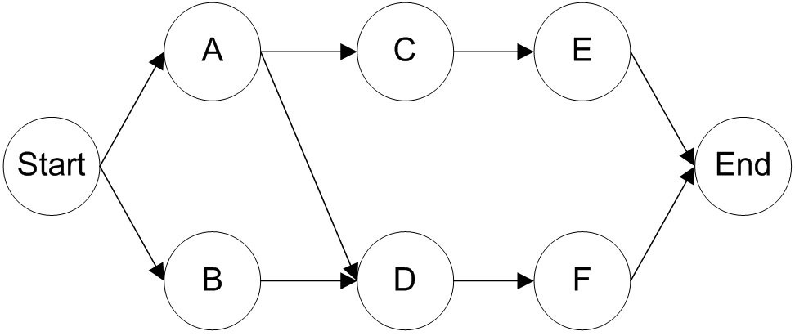

Answer: (a) Possible paths are P-S (length 22), P-R-T (length 28), and Q-T (length 21). (b) The longest of these, P-R-T, is the critical path, at (c) 28 time units. (d) There is no slack at P, R, or T since these are critical tasks. S has 6 units slack, since the path it is on totals only 22 units, compared to the critical path length of 28. Q has 7 units of slack since it is on a 21 length path, 7 less than the maximum.
Diff: 2
Topic: Project management techniques: PERT and CPM
AACSB: Analytic Skills
Objective: LO3-4

109) A network consists of the activities in the following list. Times are given in weeks.

Activity | Preceding | Time
A | -- | 8
B | -- | 3
C | A | 7
D | A, B | 3
E | C | 4

a. Draw the network diagram.
b. Calculate the ES, EF, LS, LF, and Slack for each activity.
c. What is project completion time?
Answer: (a)
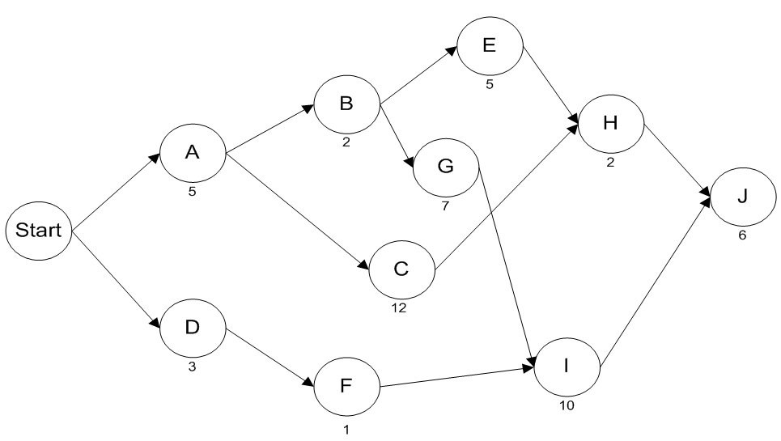

(b,c)

Results
Task | Early Start | Early Finish | Late Start | Late Finish | Slack
A | 0 | 8 | 0 | 8 | 0
B | 0 | 3 | 7 | 10 | 7
C | 8 | 15 | 8 | 15 | 0
D | 8 | 11 | 10 | 13 | 2
E | 15 | 19 | 15 | 19 | 0
F | 11 | 17 | 13 | 19 | 2
 | Project | 19

Diff: 2
Topic: Project management techniques: PERT and CPM
AACSB: Analytic Skills
Objective: LO3-3
110) The network below represents a project being analyzed by Critical Path Methods. Activity durations are A=5, B=2, C=12, D=3, E=5, F=1, G=7, H=2, I=10, and J=6.
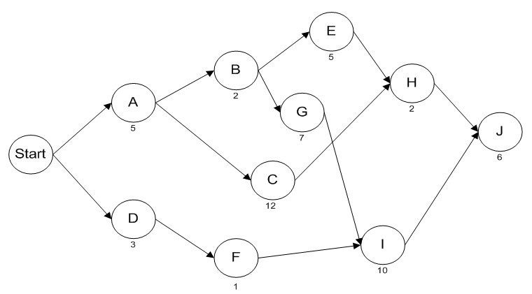
a. What task must be on the critical path, regardless of activity durations?
b. What is the duration of path A-B-E-H-J?
c. What is the critical path of this network?
d. What is the length of the critical path?
e. What is slack time at activity H?
f. What is the Late Finish of activity H?
g. If activity C were delayed by two time units, what would happen to the project duration?
Answer: (a) J; (b) 20; (c) A-B-G-I-J; (d) 30; (e) 5; (f) 24; (g) no impact.

Results
Task | Early Start | Early Finish | Late Start | Late Finish | Slack
A | 0 | 5 | 0 | 5 | 0
B | 5 | 7 | 5 | 7 | 0
C | 5 | 17 | 10 | 22 | 5
D | 0 | 3 | 10 | 13 | 10
E | 7 | 12 | 17 | 22 | 10
F | 3 | 4 | 13 | 14 | 10
G | 7 | 14 | 7 | 14 | 0
H | 17 | 19 | 22 | 24 | 5
I | 14 | 24 | 14 | 24 | 0
J | 24 | 30 | 24 | 30 | 0
 | Project | 30

Diff: 2
Topic: Project management techniques: PERT and CPM
AACSB: Analytic Skills
Objective: LO3-4
111) A network consists of the following list. Times are given in weeks.

Activity | Preceding | Duration
A | -- | 9
B | A | 2
C | A | 12
D | A | 5
E | B | 6
F | B | 8
G | C, F | 3
H | D | 2
I | H | 8
J | G, I | 6
K | E, J | 2

a. Draw the network diagram.
b. Which activities form the critical path?
c. How much slack exists at activities A and F?
d. What is the duration of the critical path?
Answer: (a) Network diagram

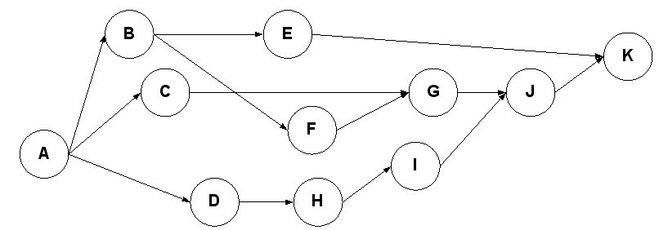

(b) paths A-D-H-I-J-K and A-C-G-J-K are critical; (c) A has no slack; F has 2 units (d) 32
weeks
Diff: 2
Topic: Project management techniques: PERT and CPM
AACSB: Analytic Skills
Objective: LO3-4
112) A partially solved PERT problem is detailed in the table below. Times are given in weeks.

Activity | Preceding | Optimistic  Time | Probable  Time | Pessimistic  Time | Expected  Time | Variance
A | -- | 7 | 9 | 14 |  | 1.361
B | A | 2 | 2 | 8 |  | 0
C | A | 8 | 12 | 16 |  | 0
D | A | 3 | 5 | 10 |  | 1.361
E | B | 4 | 6 | 8 |  | 0
F | B | 6 | 8 | 10 |  | 0
G | C, F | 2 | 3 | 4 |  | 0
H | D | 2 | 2 | 8 |  | 1.000
I | H | 6 | 8 | 16 |  | 2.778
J | G, I | 4 | 6 | 14 |  | 2.778
K | E, J | 2 | 2 | 5 |  | 0.250

a. Calculate the expected time for each activity. Enter these values in the appropriate column in the table above.
b. Which activities form the critical path?
c. What is the estimated time of the critical path?
d. What are the project variance and the project standard deviation?
e. What is the probability of completion of the project after week 40?
Answer: (a) A=9.5 B=3 C=12 D=5.5 E=6 F=8 G=3 H=3 I=9 J=7 K=2.5
(b) A-D-H-I-J-K; (c) 36.5; (d) 9.53, 3.09; (e) 0.13.
Diff: 2
Topic: Project management techniques: PERT and CPM
AACSB: Analytic Skills
Objective: LO3-4

113) Consider the network described in the table below.

Activity | Immediate  Predecessor(s) | Pessimistic | Probable | Optimistic
J | -- | 15 | 10 | 8
K | -- | 9 | 8 | 7
L | J | 10 | 6 | 5
M | J | 3 | 3 | 3
N | K,M | 9 | 5 | 1
O | K,M | 10 | 7 | 4
P | L,N | 10 | 8 | 3

a. Calculate the expected duration of each activity.
b. Calculate the expected duration and variance of the critical path.
c. Calculate the probability that the project will be completed in fewer than 30 time units.
Answer: (a) See table below. (b) Tasks J-M-N-P are critical. The sum of their expected durations is 26.00; the sum of their variances is 4.50. (c) The standard deviation along the path is = 2.12; the probability that Duration < 30 is the probability that z < (30 - 26.00)/2.12 = 1.89. The associated normal curve area is 0.97062.
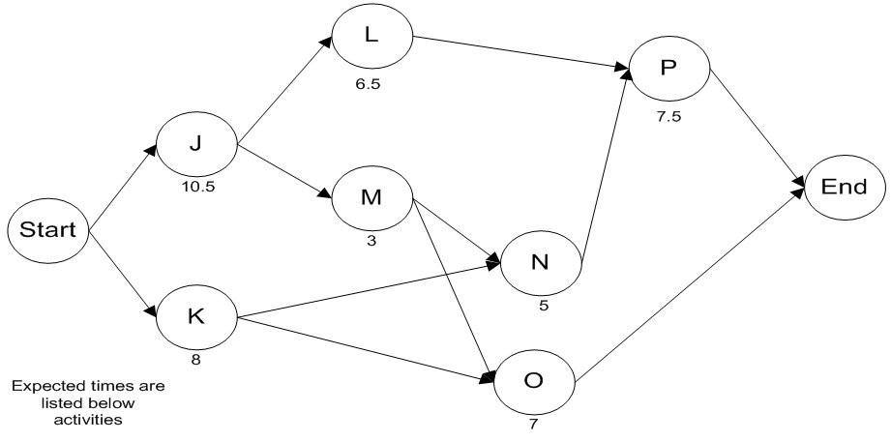

Task | Early Start | Early Finish | Late Start | Late Finish | Slack | Mean | Variance
J | 0 | 10.5 | 0 | 10.5 | 0 | 10.5 | 1.361111
K | 0 | 8 | 5.5 | 13.5 | 5.5 | 8
L | 10.5 | 17 | 19.5 | 26 | 9 | 6.5
M | 10.5 | 13.5 | 10.5 | 13.5 | 0 | 3 | 0
N | 13.5 | 18.5 | 13.5 | 18.5 | 0 | 5 | 1.777778
O | 13.5 | 20.5 | 19 | 26 | 5.5 | 7
P | 18.5 | 26 | 18.5 | 26 | 0 | 7.5 | 1.361111
 | Project | 26 |  |  |  | Project | 4.5
 |  |  |  |  |  | Std.dev | 2.12132

Diff: 2
Topic: Project management techniques: PERT and CPM
AACSB: Analytic Skills
Objective: LO3-4
114) The network below represents a project being analyzed by Critical Path Methods. Activity durations are indicated on the network.

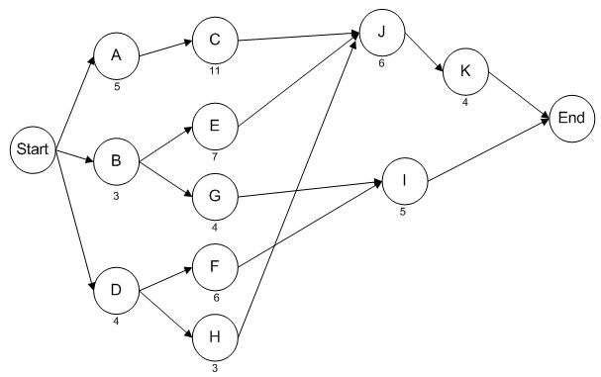

a. Identify the activities on the critical path.
b. What is the duration of the critical path?
c. Calculate the amount of slack time at activity H.
d. If activity I were delayed by ten time units, what would be the impact on the project duration?
Answer: (a) Critical activities are A-C-J-K; (b) The critical path is 26 time units; (c) Slack at H is 9 units; (d) I has 11 units slack--a ten unit delay would have no impact on the project.

Task | Early Start | Early Finish | Late Start | Late Finish | Slack
A | 0 | 5 | 0 | 5 | 0
B | 0 | 3 | 6 | 9 | 6
C | 5 | 16 | 5 | 16 | 0
D | 0 | 4 | 9 | 13 | 9
E | 3 | 10 | 9 | 16 | 6
F | 4 | 10 | 15 | 21 | 11
G | 3 | 7 | 17 | 21 | 14
H | 4 | 7 | 13 | 16 | 9
I | 10 | 15 | 21 | 26 | 11
J | 16 | 22 | 16 | 22 | 0
K | 22 | 26 | 22 | 26 | 0
 | Project | 26
Diff: 2
Topic: Project management techniques: PERT and CPM
AACSB: Analytic Skills
Objective: LO3-4

115) Three critical path activities are candidates for crashing on a CPM network. Activity details are in the table below.

Activity | Normal Time | Normal Cost | Crash Duration | Crash Cost
X | 8 days | $6,000 | 6 days | $8,000
Y | 3 days | $1,800 | 2 days | $2,400
Z | 12 days | $5,000 | 9 days | $7,700

a. What is the crash cost per unit time for each of the three activities?
b. Which activity should be crashed first to cut one day from the project's duration; how much is added to project cost?
c. Which activity should be the next activity crashed to cut a second day from the project's duration; how much is added to project cost?
Answer: (a) crash cost X = $1,000 per day; crash cost Y = $600 per day ; crash cost Z = $900 per day
(b) select Y, adding $600; (c) select Z, adding $900
Diff: 2
Topic: Cost-time trade-offs and project crashing
AACSB: Analytic Skills
Objective: LO3-6

116) Three critical path activities are candidates for crashing on a CPM network. Activity details are in the table below.

Activity | Normal Time | Normal Cost | Crash Duration | Crash Cost
A | 9 days | $8,000 | 7 days | $12,000
B | 5 days | $2,000 | 3 days | $10,000
C | 12 days | $9,000 | 11 days | $12,000

a. What is the crash cost per unit time for activity A?
b. What is the crash cost per unit time for activity B?
c. Which activity should be crashed first to cut one day from the project's duration; how much is added to project cost?
d. Which activity should be the next activity crashed to cut a second day from the project's duration; how much is added to project cost?
e. Assuming no other paths become critical, how much can this project be shortened at what total added cost?
Answer: (a) $2,000; (b) $4,000; (c) A, $2,000; (d) A again, $2,000 additional; (e) 5 days, $15,000.
Diff: 2
Topic: Cost-time trade-offs and project crashing
AACSB: Analytic Skills
Objective: LO3-6
117) A network consists of the following list. Times are given in weeks.

Activity | Preceding | Optimistic | Probable | Pessimistic
A | -- | 5 | 11 | 14
B | - | 3 | 3 | 9
C | -- | 6 | 10 | 14
D | A, B | 3 | 5 | 7
E | B | 4 | 6 | 11
F | C | 6 | 8 | 13
G | D, E | 2 | 4 | 6
H | F | 3 | 3 | 9

a. Draw the network diagram.
b. Calculate the expected duration and variance of each activity.
c. Calculate the expected duration and variance of the critical path.
d. Calculate the probability that the project will be completed in less than 28 weeks.
Answer:
(a)
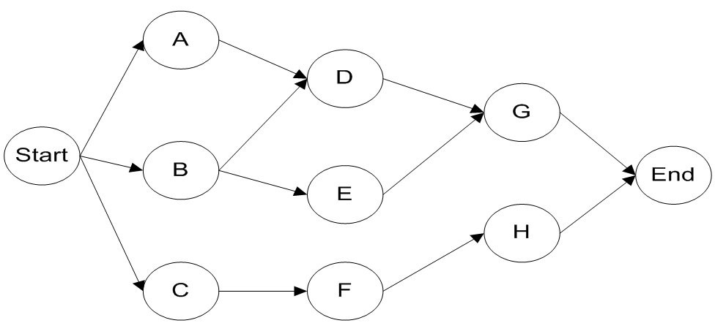

(b,c)

Task | Expected  time | Variance | Std. dev. | Slack | Variance
A | 10.5 | 2.25 | 1.5 | 3
B | 4 | 1 | 1 | 8
C | 10 | 1.778 | 1.333 | 0 | 1.778
D | 5 | 0.444 | 0.667 | 3
E | 6.5 | 1.361 | 1.167 | 8
F | 8.5 | 1.361 | 1.167 | 0 | 1.361
G | 4 | 0.444 | 0.667 | 3
H | 4 | 1 | 1 | 0 | 1
Project | 22.5 |  |  | Project | 4.139
 |  |  |  | Std. dev. | 2.034

(d) z = (28-22.5)/2.03 = 2.71, (P<=28) = .997
Diff: 2
Topic: Project management techniques: PERT and CPM
AACSB: Analytic Skills
Objective: LO3-5
118) Draw the AOA and AON networks for the following project and calculate the minimum project duration.

Activity | Duration  (days) | Immediate  Predecessors
A | 10 | ---
B | 8 | ---
C | 2 | A
D | 4 | A
E | 5 | B,C, D

Answer: AON
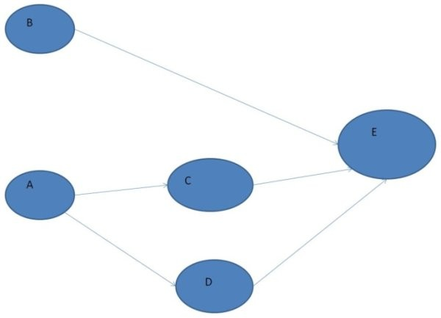

AOA
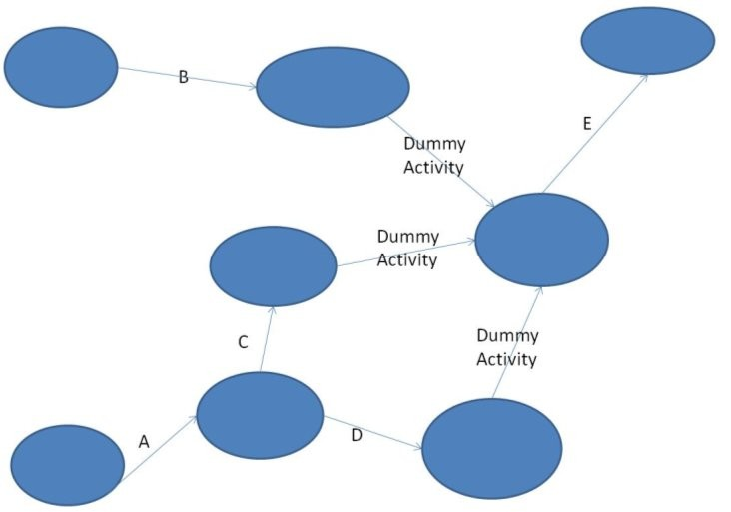

Minimum duration is the longest of the three paths, ADE, or a total of 19 days.
Diff: 2
Topic: Project management techniques: PERT and CPM
AACSB: Analytic Skills
Objective: LO3-2
119) Given the project within the table below calculate
a. The critical path
b. The minimum project duration
c. The amount of slack for each activity

Activity | Duration (hours) | Immediate Predecessors
A | 4 | None
B | 3 | None
C | 10 | None
D | 7 | B,C
E | 1 | D
F | 1 | E
G | 5 | A,F

Answer:
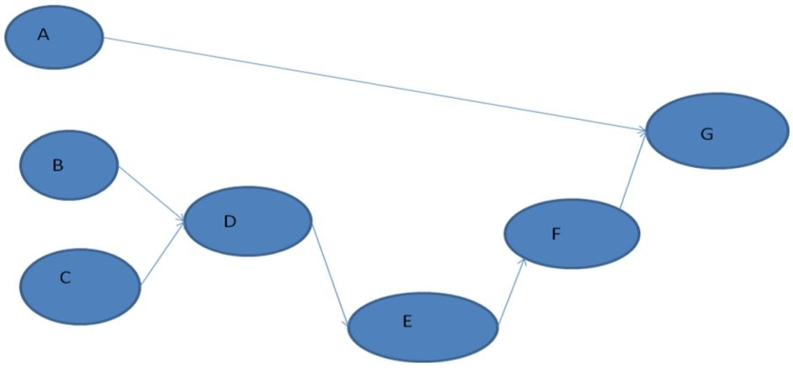

(A) The critical path is CDEFG
(B) Minimum duration is (10+7+1+1+5) or 24 hours
(C) CDEFG have no slack since on the critical path. BDEFG takes 17 hours, so B has 7 hours of slack. AG takes 9 hours, so A has 15 hours of slack.
Diff: 2
Topic: Cost-time trade-offs and project crashing
AACSB: Analytic Skills
Objective: LO3-4

120) Pirmin's Bike Shop is behind on a custom bike and needs to crash 8 hours of time from the 8-step project. Given the project table below calculate the crash cost for 8 hours of time-savings. Suppose Pirmin calls the customer and asks for a project extension, reducing the amount of time he needs to crash. Calculate both the maximum time-savings available on a $25 crash budget and the cost to crash four hours of savings.

Activity | Normal  Duration (hours) | Normal  Cost ($) | Crash  Duration (hours) | Crash  Cost (S) | Immediate  Predecessors
A | 2 | 10 | 2 | 0 | None
B | 3 | 15 | 2 | 23 | A
C | 5 | 25 | 4 | 30 | B
D | 3 | 20 | 1 | 24 | C
E | 6 | 30 | 4 | 45 | C
F | 1 | 5 | 1 | 0 | C,E
G | 7 | 35 | 6 | 50 | F
H | 10 | 50 | 7 | 80 | D,G

Answer:
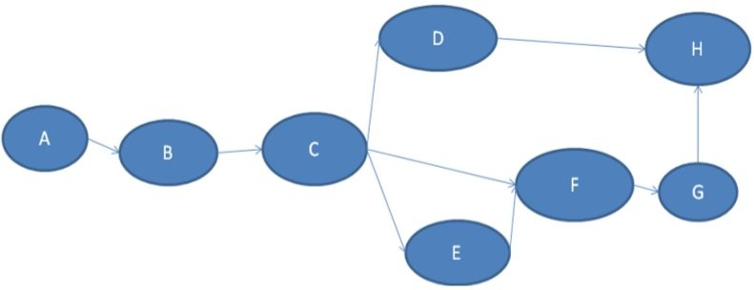

The critical path is ABCEFGH with a time of 34 hours. The cost per crash hour for these activities are 8(B), 5(C), 2(D), 7.5(E), 15(G), 10(H). C will be crashed first for a savings of 1 hour. Next E will be crashed for a savings of 2 hours. Then B can be crashed for a savings of 1 hour. Next H will be crashed for a savings of 3 hours, netting 7 hours total at a cost of (5+15+8+30) $58. Only 1 more hour is needed, so G will be crashed for an additional 15 dollars, netting 8 hours saved at a cost of 58+15 = $73. D was not crashed because it does not lie on the critical path after any amount of crashing (E always > D). With $25 only C and E can be crashed, saving 3 hours of time and spending $20. A fractional component of B could be crashed (5/8) of an hour to spend the entire $25, however most students should interpret this question as only whole-hour increments. The cost to crash four hours would be C+E+B crashing = $28.
Diff: 3
Topic: Cost-time trade-offs and project crashing
AACSB: Analytic Skills
Objective: LO3-6
121) Given the critical path below, calculate the following
a. The crash cost per unit time savings for each activity.
b. The maximum total crash time savings and cost.
c. The maximum total time-savings with a $3000 budget.

Activity | Normal Time | Normal Cost | Crash Duration | Crash Cost
A | 8 days | $8,000 | 7 days | $12,000
B | 5 days | $2,000 | 3 days | $10,000
C | 10 days | $9,000 | 9 days | $12,000

Answer:
(A) A saves 1 day for $4000/day, B saves 2 days for $4000/day, C saves 1 day at $3000/day.
(B) Max time savings is A+B+C = 4 days for a total of $15,000
(C) 1 day could be crashed from C. This means maximum savings is 1 day.
Diff: 2
Topic: Cost-time trade-offs and project crashing
AACSB: Analytic Skills
Objective: LO3-6
122) Consider the network presented in the following table. Calculate
a. All possible paths
b. The critical path
c. The slack available at any non-critical points
d. The minimum project duration

Task | Duration (Days) | Immediate Predecessors
A | 5 | None
B | 3 | A
C | 4 | A
D | 2 | C
E | 1 | B,D

Answer:
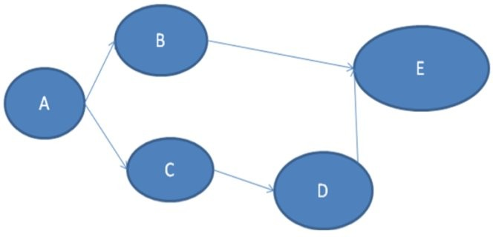

(A) Two paths are possible, ACDE and ABE.
(B) The critical path is ACDE
(C) The slack available at point B is Duration (ACDE) — Duration (ABE) = 3 days. All other points have no slack because they are on the critical path.
(D) The minimum project duration is the length of the critical path ACDE which is = 12 days
Diff: 2
Topic: Project management techniques: PERT and CPM
AACSB: Analytic Skills
Objective: LO3-4

